Results

• Demographics

Our sample consisted of 78 total participants. The participants were collected through a convenience sample of the researchers friends and family. One participant attempted to take the online survey, but was immediately denied due to being under 18 years of age.

In general, our sample had an average age of 28 years old. However, the age ranged from 20 years old to 53 years old. Next, for the most part, a majority of the participants were White, followed by Hispanic and only 1 participant chose not to indicate their race. Figure 1 shows how the participants race represented in this sample.

*Figure 1*

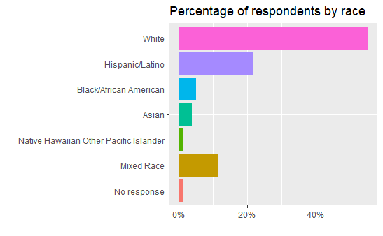

Next, the sample collected was majority female, with female representing 71% of the sample. When looking at education level, it is clear to see that the majority of participants are highly educated, with over 35% of individuals having obtained past a bachelor’s degree when asked, “What is the HIGHEST level of education that you completed?” *Figure 2* indicates the percentage of respondents that filled each education level category.

*Figure 2*

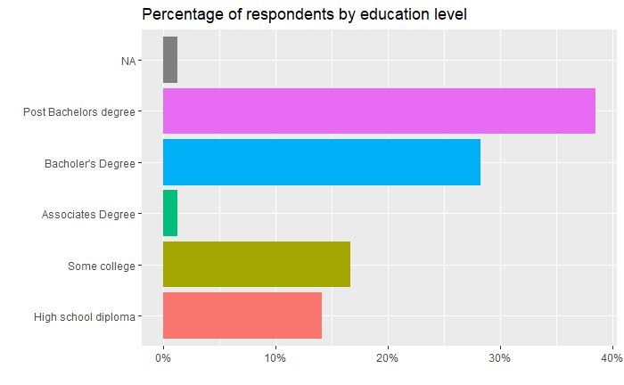

• Item and Scale‐level Descriptive Statistics (see example report for one way to present this)

**\*Scales to be described before\***

Below are tables indicating the item level statistics for the **perceived stress scale**

|  |  |  |
| --- | --- | --- |
| Item | N | Average Score |
| How often have you been upset because of something that happened unexpectedly? | 78 | 2.09 |
| How often have you felt that you were unable to control the important things in your life? | 77 | 2.13 |
| How often have you felt nervous and “stressed”? | 78 | 2.83 |
| How often have you felt confident about your ability to handle your personal problems? | 78 | 1.30 |
| How often have you felt that things were going your way? | 78 | 1.51 |
| How often have you found that you could not cope with all the things that you had to do? | 78 | 1.97 |
| How often have you been able to control irritations in your life? | 78 | 2.55 |
| How often have you felt that you were on top of things? | 78 | 1.69 |
| How often have you been angered because of things that were outside of your control? | 78 | 1.86 |
| How often have you felt difficulties were piling up so high that you could not overcome them? | 78 | 1.80 |
| Total scale statistics | 78 | 16.35 |

**Below is a table represing item level reposnes to the Learning orientations scale:**

**\*Cognitive subscale\***

|  |  |  |
| --- | --- | --- |
|  | N | Average Score |
| I believe that I can become an expert at anything if I work hard enough (1) | 78 | 5.0 |
| I believe that I can change my abilities or performance through hard work (2) | 78 | 5.18 |
| I believe that success in life is mostly influenced by effort (3) | 78 | 4.80 |
| I believe that setbacks are temporary (4) | 78 | 4.86 |
| I believe challenges are opportunities to learn (5) | 78 | 5.21 |
| I believe that setbacks are valuable parts of my personal growth (6) | 78 | 4.96 |
| Total Scale Statistics | 78 | 7.90 |

\***Behavioral Subscale\***

|  |  |  |
| --- | --- | --- |
|  | N | Average Score |
| When I encounter roadblocks I work tirelessly to overcome them | 78 | 4.54 |
| When I am given critical feedback I find new ways of doing things to solve a problem (When someone criticizes me I give up) | 78 | 4.10 |
| I strive to do my best on a project even when I am struggling with it | 78 | 4.97 |
| When I experience set backs, I give up | 78 | 4.80 |
| I feel proud of my effort even if I don’t succeed | 78 | 4.32 |
| Total Scale Statistics | 78 | 17.41 |

\***Affective Subscale* (This is the scale that is predictive of stress)**

|  |  |  |
| --- | --- | --- |
|  | N | Average Score |
| I feel eager to take on new challenges | 78 | 4.93 |
| I feel proud of my effort even if I don’t succeed | 78 | 4.01 |
| I feel confident that I can overcome any obstacles I am presented with | 78 | 4.67 |
| I feel enjoyment when learning new skills | 78 | 4.26 |
| Total Scale Statistics | 78 | 7.76 |

Summary of additional analyses and presentation of additional results relevant to the project (such as a summary of correlations, regression analysis, t‐tests, ANOVA, etc. to address the purpose of the project).

**In general, the main finding is that higher scores on the affective learning orientation subscale are highly correlated with perceived stress among the sample. This indicates that individuals that have an eagerness to try new things and are happy to be presented with new challenges, actually tend to have a higher amount of perceived stress. Surprisingly, none of the other factors of learning orientation (behavioral and cognitive) tended to be as related to perceived stress one experiences. This is an indication that being eager to take on new tasks is a higher contributor to being stressed out.**

**Additionally, in general, females tend to have higher levels of stress in our sample (Which I think supports past research)**

Missing Data – report and summarize how you handled missing data. If your results for this section are very detailed, determine whether any of those details are best presented in a technical appendix rather than the main body of the report.

**For the most part, we had relatively little missing data. Of all of our scales of interest, only 1 participant did not answer an item on the perceived stress scale. Additionally, If individuals had missing data on gender, they were removed from the analysis portion. Also, the missing items are reported within our demographic variables.**